EXPERIMENT – 6
TO UNDERSTAND EDA – QUANTITATIVE AND QUALITATIVE
Aim:
To understand quantitative and qualitative of EDA
Procedure:
- Import all the necessities
- Upload default dataset ‘tips’
- Use pandas to read and make it as DataFrame
- Then perform various plots and joints using seaborn and other libraries

Program:
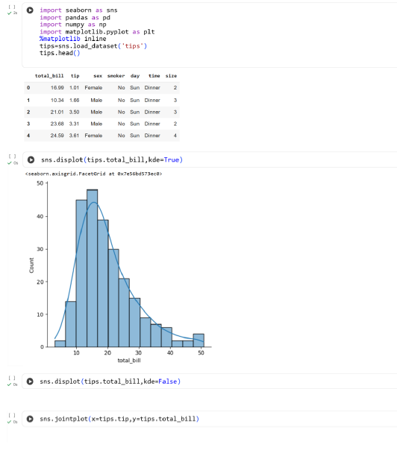

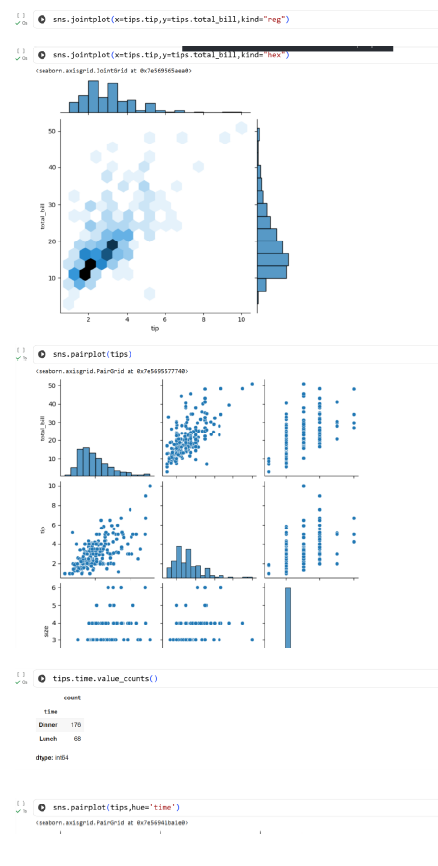
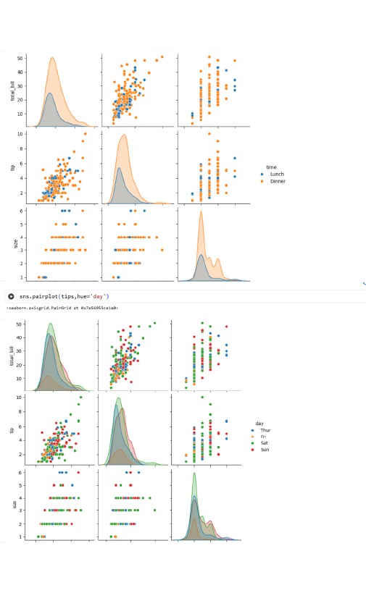

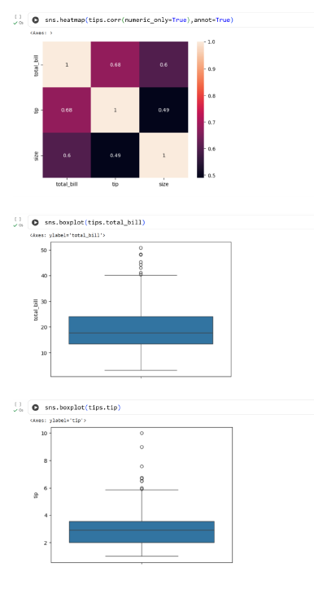
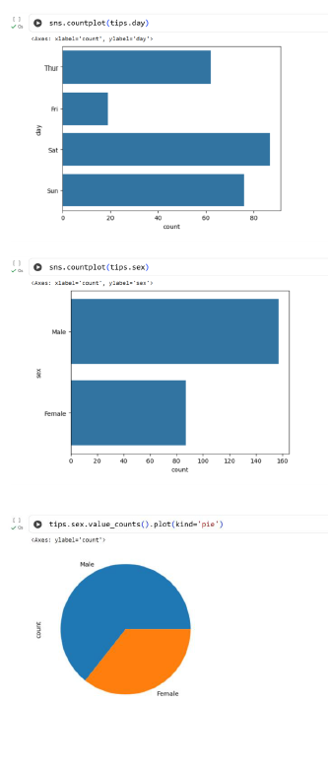

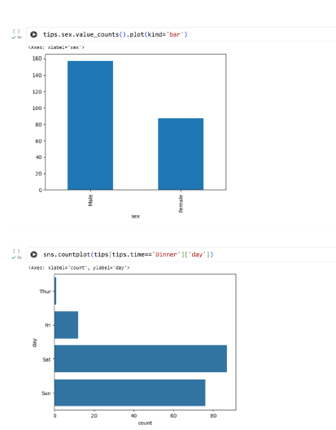
Result:
Thus the python program to understand EDA is executed and verified successfully

